Receptor Selection: Serum Albumin vs Fatty Acid Binding Protein
Notebook: ReceptorSelection_SA_FABP.ipynb
Dataset: New_4FAData_Notebook.xlsx, Old_4AData_Notebook.csv

Feature [1, 2, 3, 4, 5, 6, 7, 8, 9, 10, 11] | Serum Albumin | Fatty Acid Binding Proteins (FABPs)
Primary Location | Extracellular (Blood plasma and interstitial fluid). | Intracellular (Cytosol, nucleus, and cell membranes of various tissues).
Primary Function | Bulk transport of fatty acids, buffering FA levels in the blood, and carrying diverse metabolites/drugs. | Intracellular trafficking, targeting FAs to enzymes, and activating gene transcription via nuclear receptors (e.g., PPARs).
Number of Binding Sites | Multiple. Has about 7 distinct binding sites, with varying affinities (ranging from high to weak). | Usually One (1 FA per protein). Exception: Liver-type FABP (L-FABP) which binds two.
Binding Capacity | High capacity (holds a large volume of FA in the blood). | High affinity (binds very tightly to FAs, usually with \(K_{d}\) values in the nanomolar range).
Structure | A large, heart-shaped, multi-domain, α-helical protein. | A compact β-barrel structure (a water-filled internal cavity capped by α-helices).
Ligand Selectivity | Broad and non-specific. Binds a wide range of FAs, drugs, hormones, and ions. | Variable but specific to the tissue. Different isoforms (e.g., Heart H-FABP, Liver L-FABP, Brain B-FABP) specialize in distinct lipid chains.
High binding affinity does not automatically mean fluorescence intensity increases; binding affinity determines when the change happens, not the direction of the signal. [1]
The Crucial Distinction
- Binding Affinity: Dictates how much ligand is needed to trigger a change. High affinity means you see a signal change at very low ligand concentrations. [1]
- Fluorescence Intensity: Depends entirely on the chemical environment of the fluorophore. When binding occurs, the intensity can increase, decrease (quenching), or stay the same. [1, 2, 3, 4]

Serum Albumin: Higher Capacity, Lower Affinity
Higher Fluorescence Intensity More Detection Power for Fatty Acids
Experiment Comparison
Top 4 FA Differentiation by binding with Serum Albumin
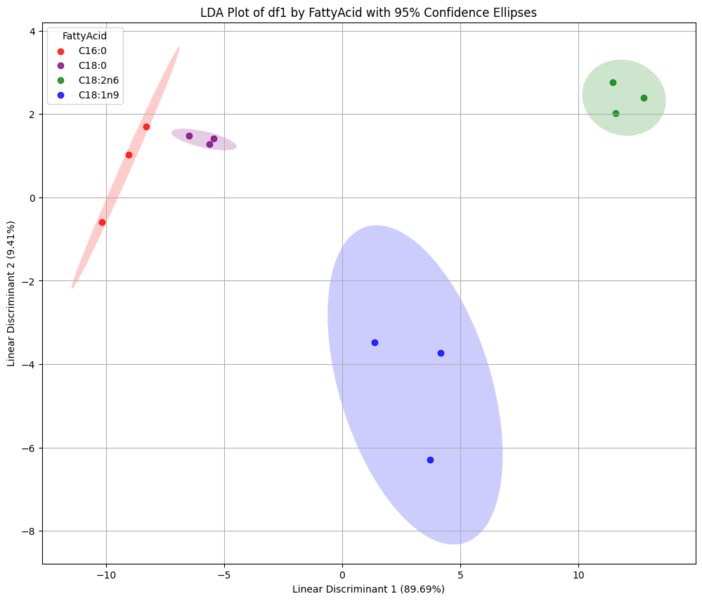
LOOCV Accuracy Scores: [1. 1. 1. 1. 1. 1. 1. 1. 1. 1. 1. 1.] Mean LOOCV Accuracy: 1.0000

Top 4 FA Differentiation by binding with FABP
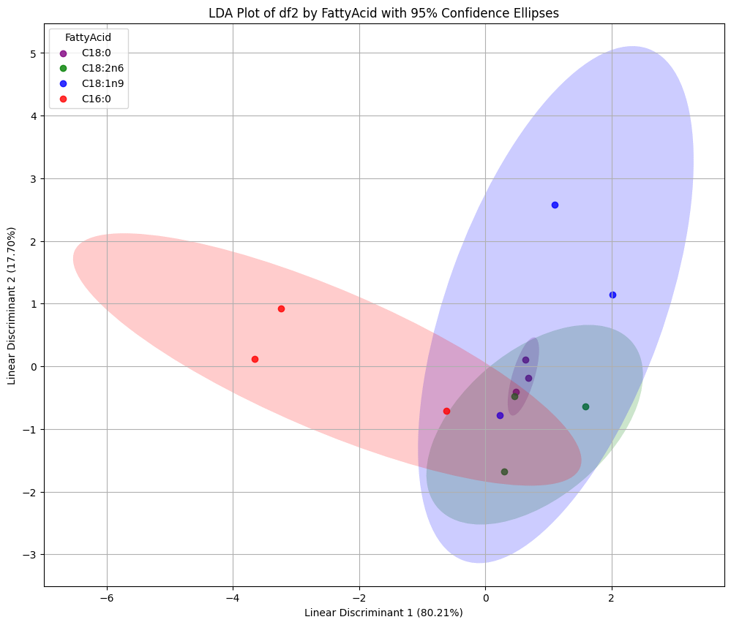

LOOCV Accuracy Scores for df2: [0. 0. 0. 0. 0. 0. 0. 0. 1. 0. 1. 1.] Mean LOOCV Accuracy for df2: 0.2500

